**Lesson 11 – Class Activity**

1. Were you in class today (6 pts)?
2. Were you in class on time (3 pts)?
3. (1 pt.) When would you work with a t-distribution compared to a z-distribution when doing a confidence interval or hypothesis test for one mean?

**We use the t-distribution when the population standard deviation is not known**

**We use the z-distribution when the population standard deviation is known**

1. (1 pt) Construct a 90% and 95% confidence interval using the runner weight data is the SPSS data folder. State and interpret the 90% and 95% confidence intervals.

**We are 90% confident that the true mean weight is between 60.16 and 63.56 kg.**

**We are 95% confident that the true mean weight is between 59.81 and 63.91 kg.**

1. (1 pt) Say you work as an analyst for an athletic clothing company, and your director tells you that the mean weight for male runners is 56 kg. What would you tell your boss based on the confidence intervals that you created in problem 4?

**56 kg is outside of both confidence intervals. With high confidence, you can mention to your boss (in a loving way) that your boss is incorrect.**

1. Now that you understand hypothesis testing, you believe that the mean wage for students in Brother Cromar’s class is higher than the minimum wage is Idaho of $8.00/hour which is 75 cents higher than the national minimum wage. Use the Class Survey data to determine if the mean wage of the classes is higher than $8.50/hour using the level of significance of α=0.05. Assume that the data comes from a simple random sample.
2. (1 pt.) Create a histogram and show the mean and standard deviation of student wages. Based on that information, describe what you observe with student wages.

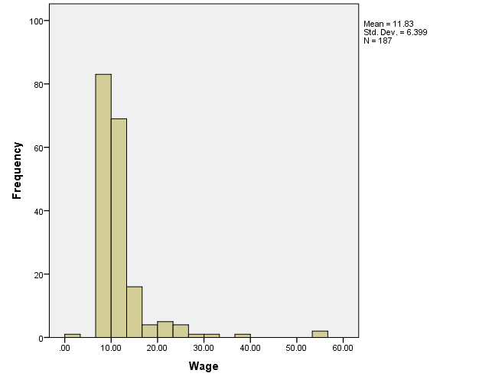

**The mean is higher than $8.50/hour. Also, the data appear to be right-skewed**

1. (1 pt.) What are the assumptions when doing this type of hypothesis test?

* **The data comes from a random sample**
* **The distribution of sampling means is bell-shaped.**

1. (1 pt.) Check the requirement or assumption that the distribution of sampling means is bell-shaped.

**Since the sample size is large, we can assume that the distribution of sample means is bell-shaped. Remember, the distribution of sample means is normal if either: 1) the sample size is large or 2) the original population is normal (we check by doing a QQ plot of the data)**

1. (1 pt.) State the null and alternative hypothesis

**Ho: µ=$8.50 Ha: µ>$8.50**

1. (1 pt.) Compute the Sample Test Statistic for this analysis

**t = 7.113**

1. (1 pt.) What are the degrees of freedom in this analysis?

**df=186**

1. (1 pt.) Determine P-Value based on Test Statistic. **P-value = close to zero**
2. (1 pt.) What decision do you make based on the P-value and the level of significance (α).

**Since the p-value is less than α, we would reject the null hypothesis**

1. (1 pt) State your conclusion.

**We have sufficient evidence to say that the population mean wage is greater than $8.50**